LAB EXPERIMENT RECORD
SET 5: WEBSITE ANALYTICS
Department | AI & DS
Course Code / Course Name | DSA0602 / Data Handling and Visualization
Experiment | Data Visualization using R
Name | M V Raghavan
Register Number | 192424373
Date | 01 October 1 2026
Day | Thursday
SET 5: WEBSITE ANALYTICS
Dataset: Website Traffic
Date | Page Views | Click-through Rate
2023-01-01 | 1500 | 2.3%
2023-01-02 | 1600 | 2.7%
2023-01-03 | 1400 | 2.0%
2023-01-04 | 1650 | 2.4%
2023-01-05 | 1800 | 2.6%
PROGRAM 1: Daily Website Page Views
Create a line chart to visualize the trend in daily page views over time. Label the axes and title the chart.
# Dataset
date <- as.Date(c("2023-01-01",
"2023-01-02",
"2023-01-03",
"2023-01-04",
"2023-01-05"))
page_views <- c(1500, 1600, 1400, 1650, 1800)
ctr <- c(2.3, 2.7, 2.0, 2.4, 2.6)
website <- data.frame(date, page_views, ctr)
# Line Chart
plot(website$date,
website$page_views,
type = "o",
main = "Daily Website Page Views",
xlab = "Date",
ylab = "Page Views",
pch = 19)
Output 1: Daily Website Page Views
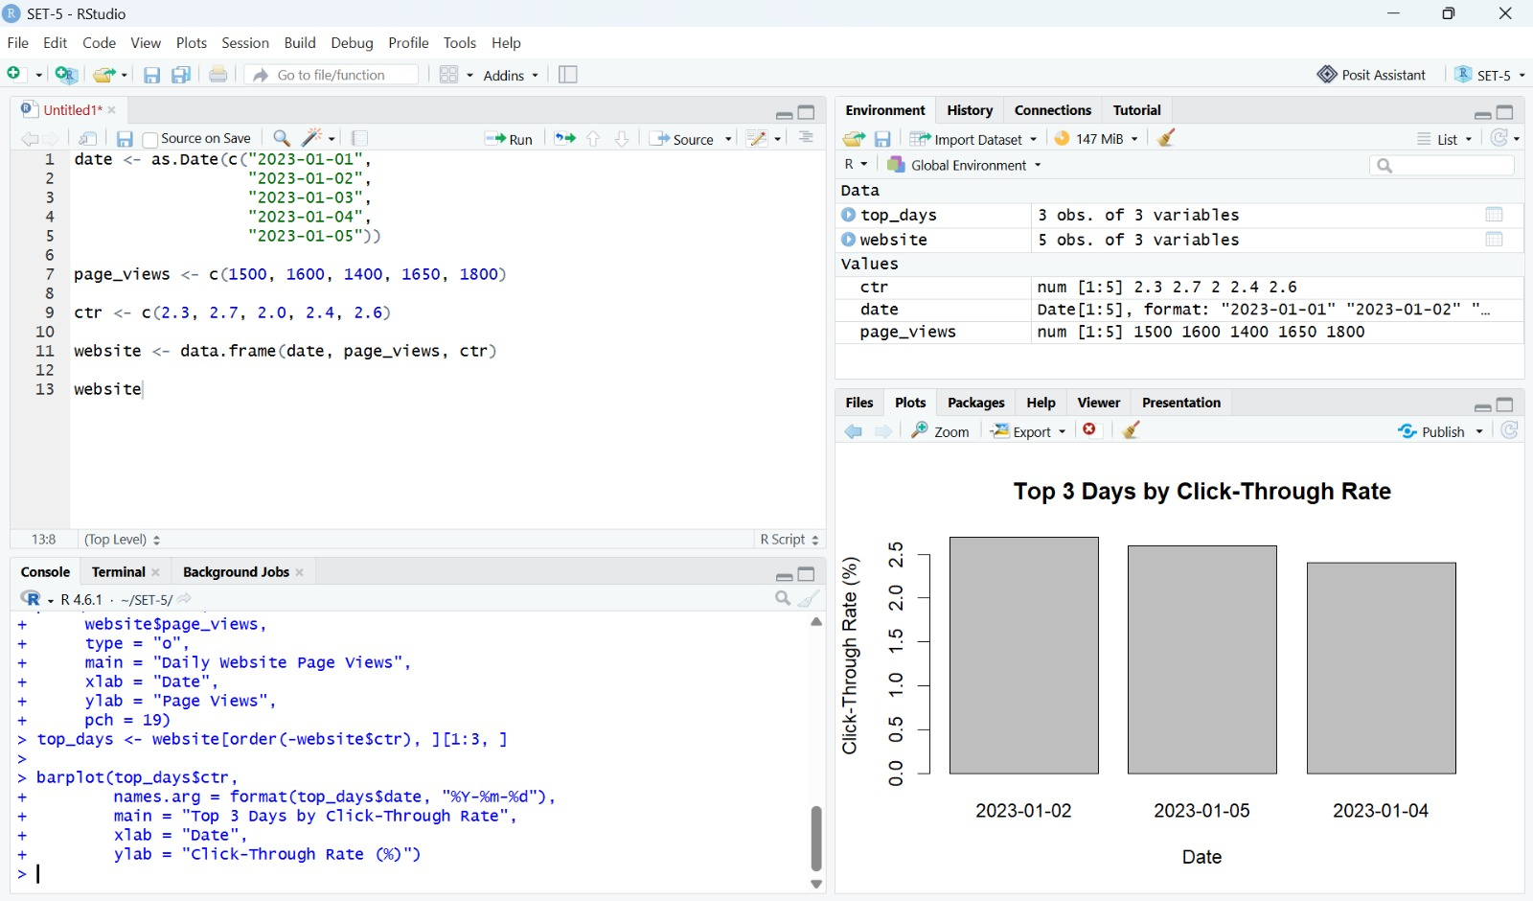
Observation: The line chart shows daily page views fluctuating across the five dates, with the highest value on 2023-01-05.
PROGRAM 2: Top 3 Days by Click-Through Rate
Generate a bar chart showing the top N days with the highest click-through rates. Label the chart elements.
# Top N days by click-through rate
top_days <- website[order(-website$ctr), ][1:3, ]
barplot(top_days$ctr,
names.arg = format(top_days$date, "%Y-%m-%d"),
main = "Top 3 Days by Click-Through Rate",
xlab = "Date",
ylab = "Click-Through Rate (%)")
Output 2: Top 3 Days by Click-Through Rate
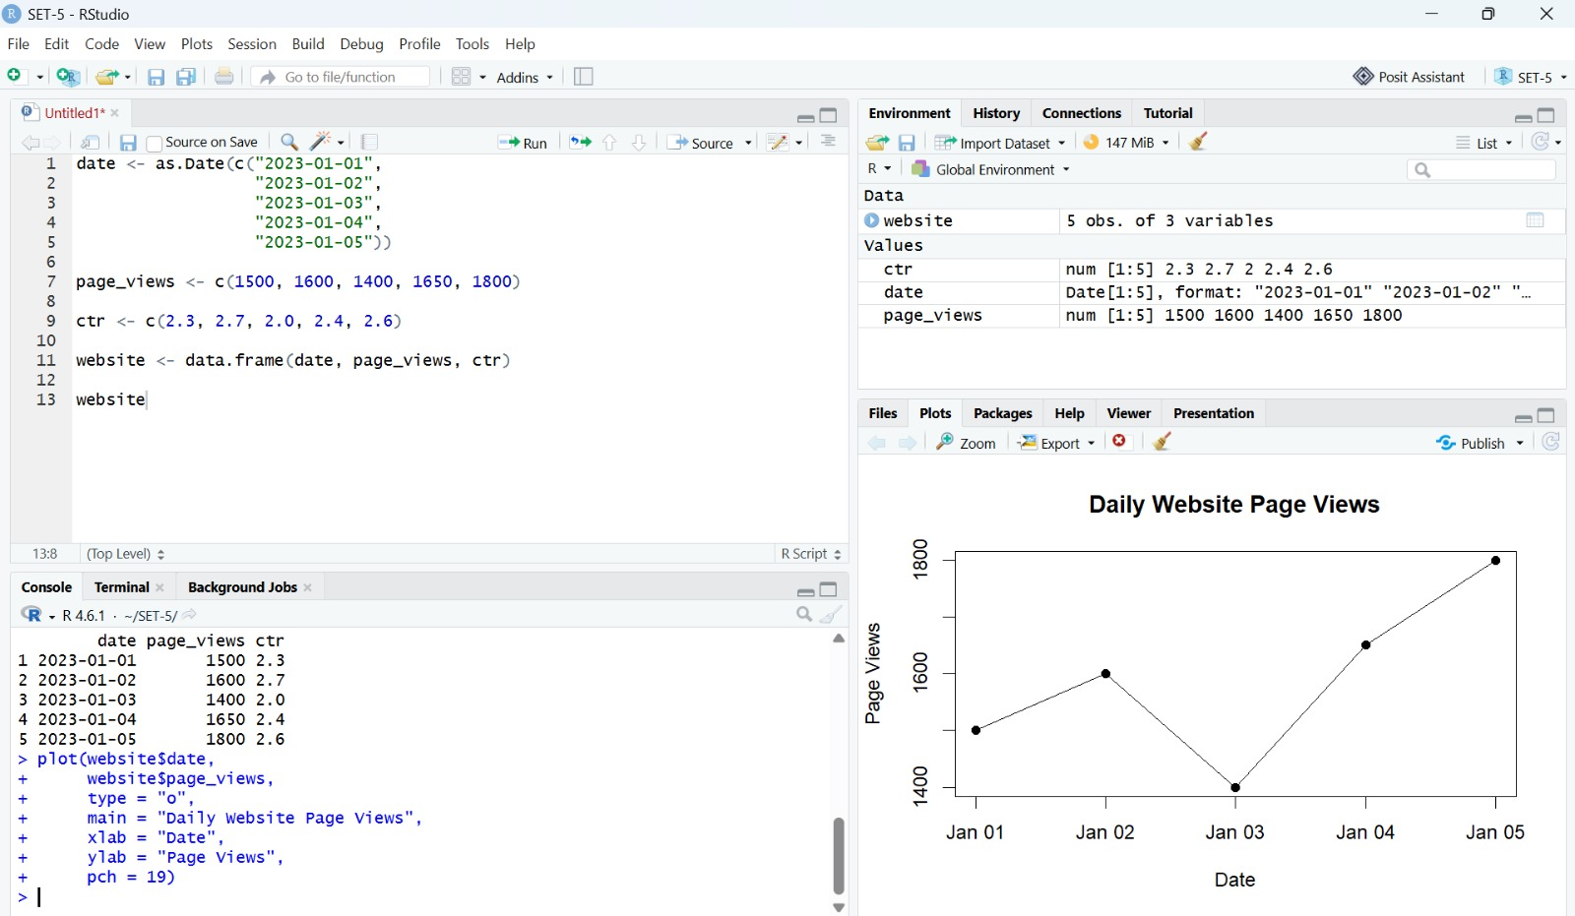
Observation: The top three days by click-through rate are 2023-01-02, 2023-01-05, and 2023-01-04.
PROGRAM 3: Website User Interactions
Develop a stacked area chart to display the distribution of user interactions (likes, shares, comments) on a website.
# User interaction data
interactions <- data.frame(
date = date,
Likes = c(500, 550, 480, 600, 650),
Shares = c(100, 120, 90, 130, 150),
Comments = c(50, 60, 45, 70, 80)
)
interaction_matrix <- t(as.matrix(interactions[, 2:4]))
# Stacked Area Chart
plot(interactions$date,
interaction_matrix[1, ],
type = "n",
main = "Website User Interactions",
xlab = "Date",
ylab = "Number of Interactions")
polygon(c(interactions$date, rev(interactions$date)),
c(interaction_matrix[1, ],
rev(interaction_matrix[1, ])),
col = "lightgreen")
polygon(c(interactions$date, rev(interactions$date)),
c(interaction_matrix[1, ] + interaction_matrix[2, ],
rev(interaction_matrix[1, ])),
col = "orange")
polygon(c(interactions$date, rev(interactions$date)),
c(interaction_matrix[1, ] + interaction_matrix[2, ] + interaction_matrix[3, ],
rev(interaction_matrix[1, ] + interaction_matrix[2, ])),
col = "lightblue")
legend("topleft",
legend = c("Likes", "Shares", "Comments"),
fill = c("lightgreen", "orange", "lightblue"))
Output 3: Website User Interactions
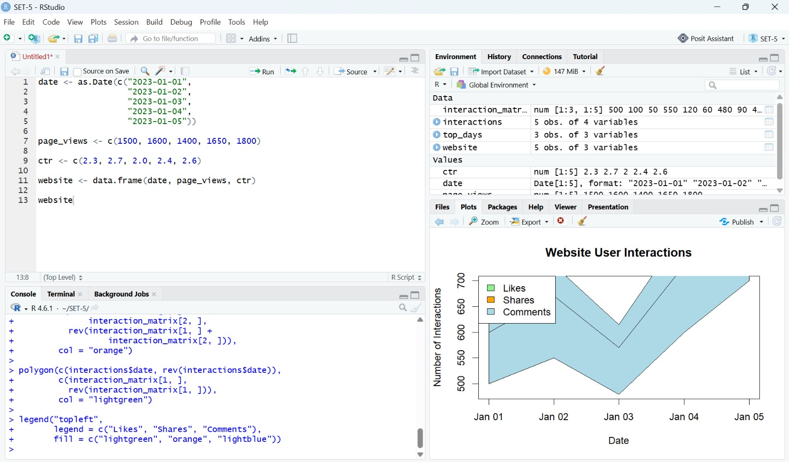
Observation: The stacked area chart displays the distribution of likes, shares, and comments across the five dates.
PROGRAM 4: Tableau Dashboard
Build a Tableau dashboard with the line chart and bar chart for interactive exploration of website traffic data.
Set 5 Procedure
1. Create vectors for dates, page views, and click-through rates.
2. Use plot() with type = "o" to represent the daily page-view trend.
3. Sort the website data by click-through rate and use barplot() to display the top three days.
4. Prepare likes, shares, and comments and use polygon() to display the stacked area chart.
5. Use the line chart and click-through-rate bar chart as the visualizations for the Tableau dashboard.
Set 5 Result
The website traffic data was visualized using a line chart, top-three click-through-rate bar chart, and stacked area chart.

